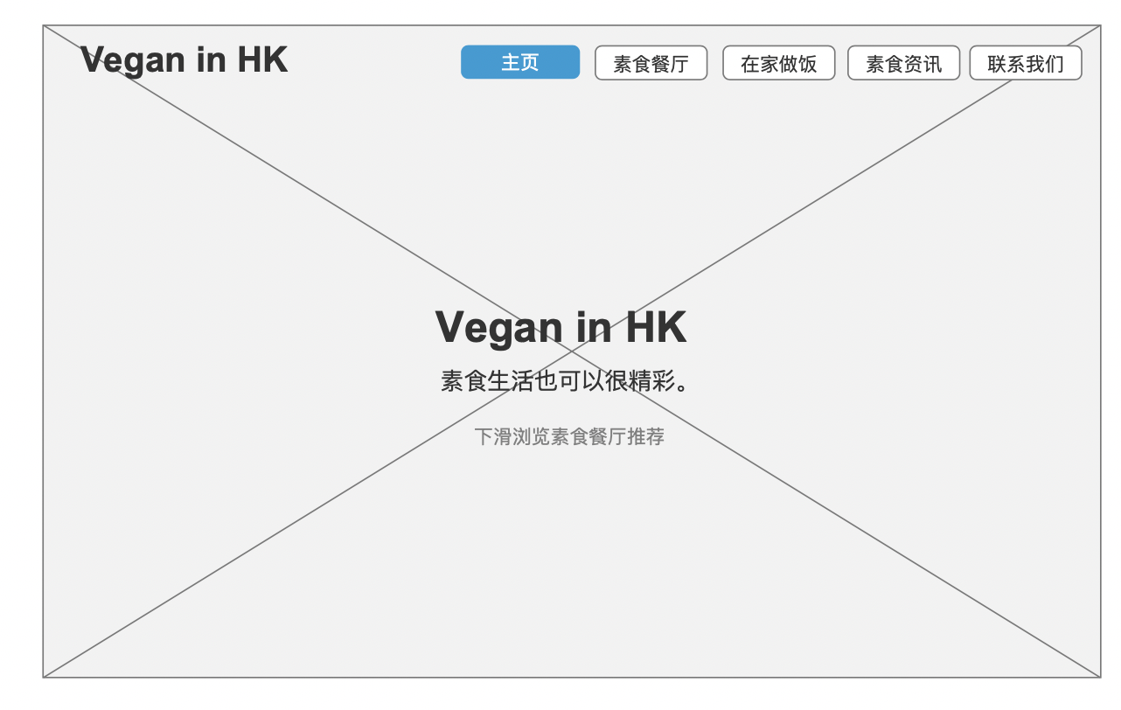

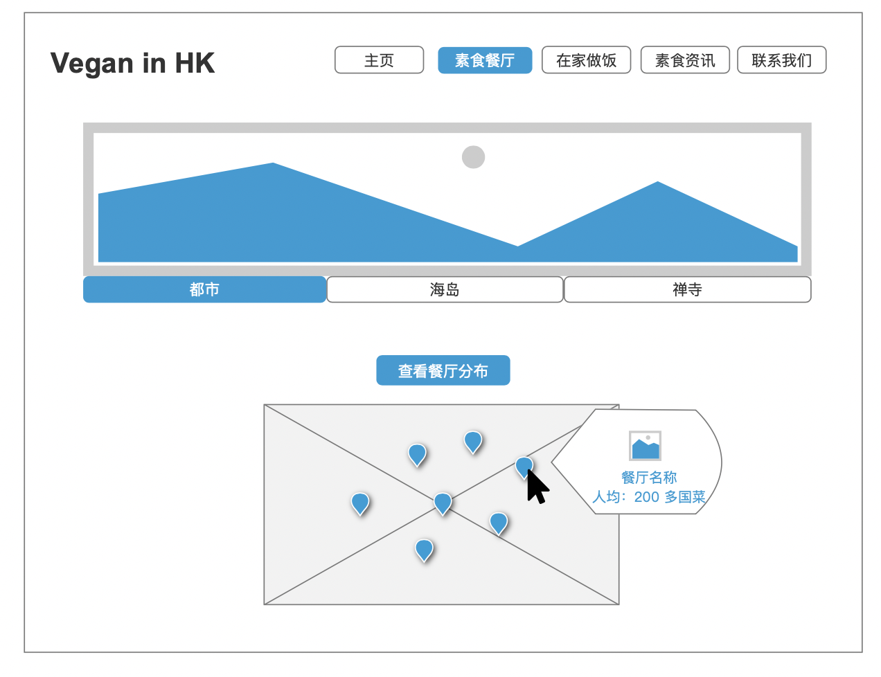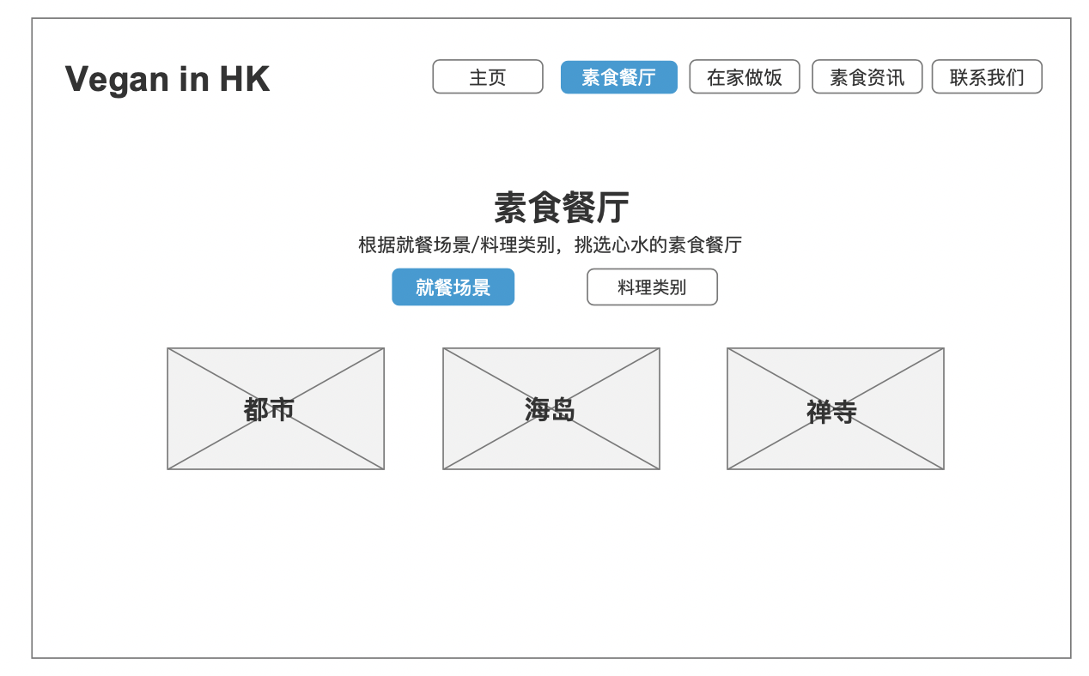

Figure 2.2 Vegan restaurants recommend (By Scene)

Map function

Figure 2.1 Vegan restaurants recommend (By Scene)

Figure 1.1 Homepage

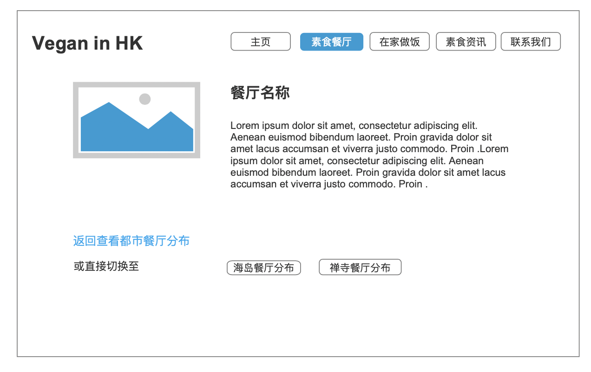

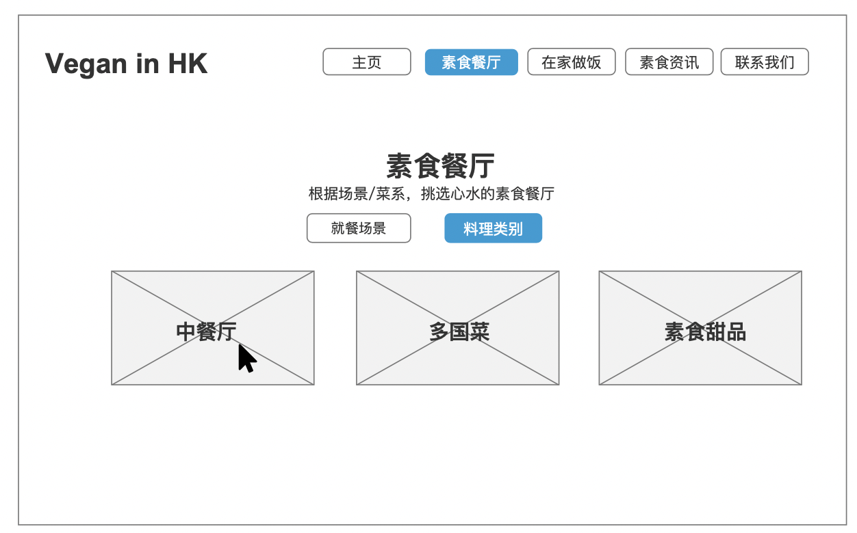

2.3 Vegan restaurants recommend (By Scene)

Map function-Details

2.4 Vegan restaurants recommend (By Cuisine)

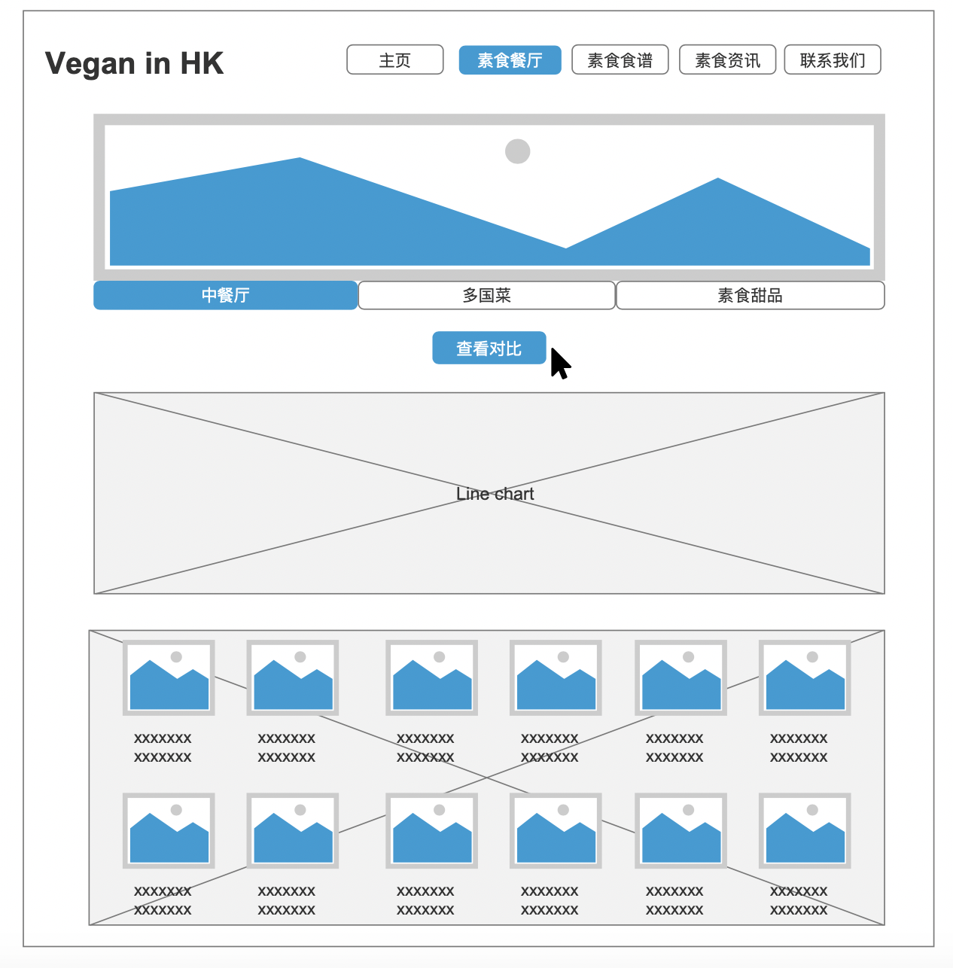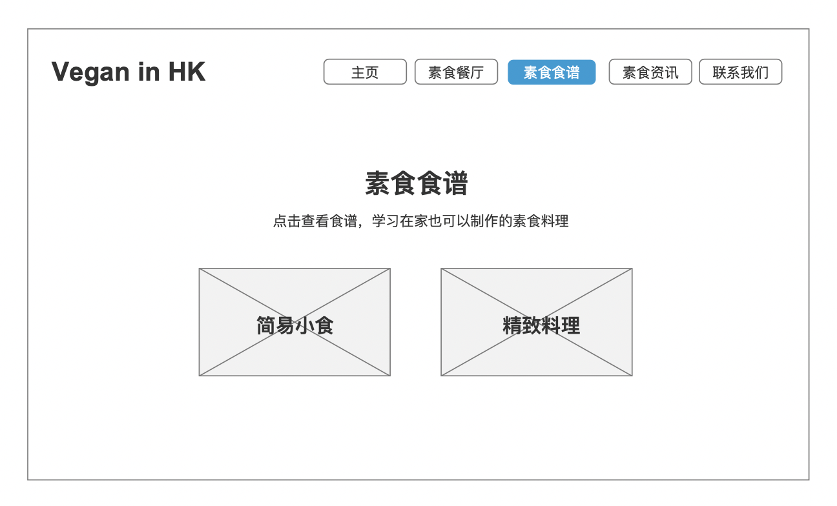

3.1 Vegan recipes (Easy and fast dish)

2.4 Vegan restaurants recommend (By Cuisine)

Compare function

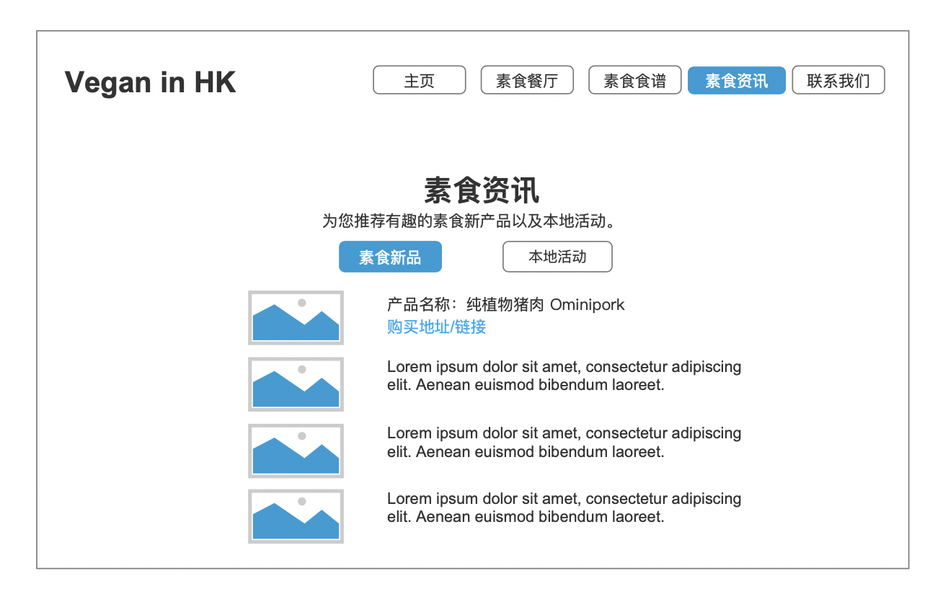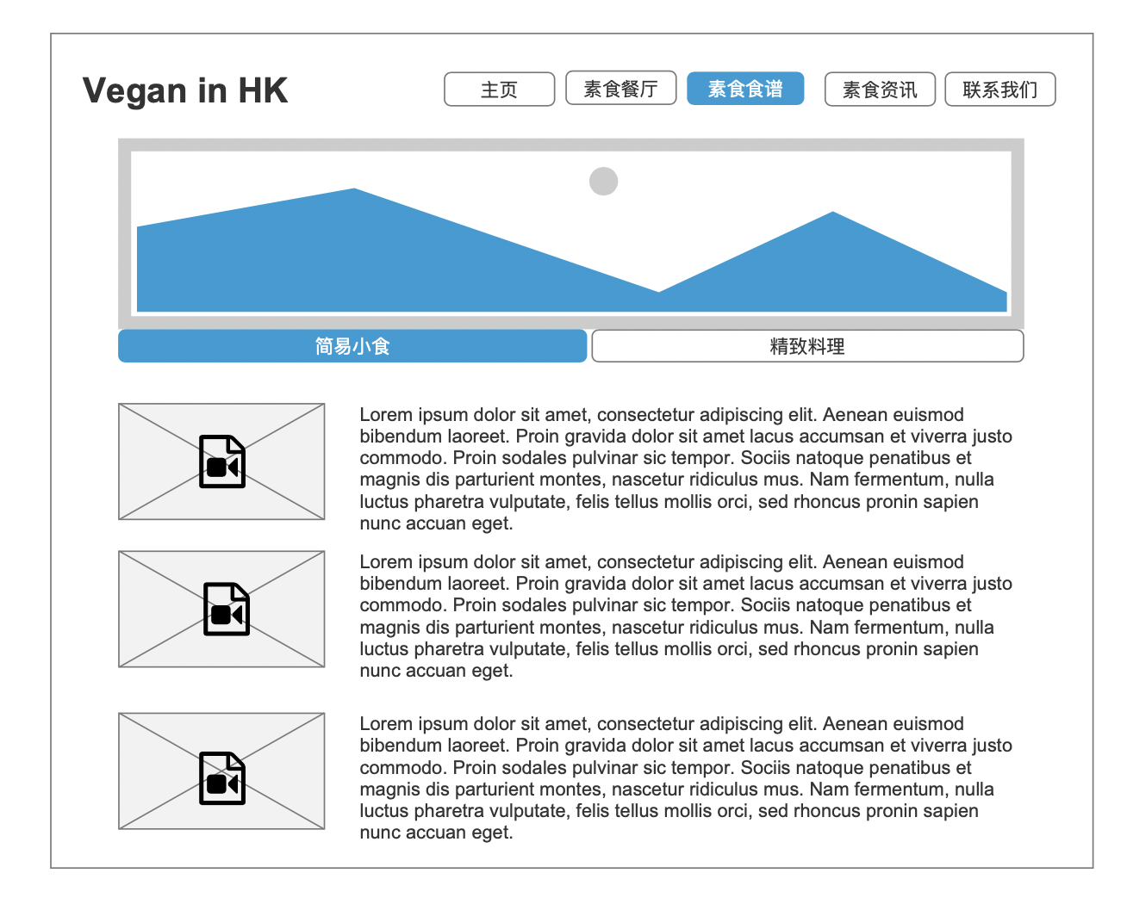

4.1 Vegan news

3.2 Vegan recipes (Easy and fast dish)

Video and details